Cognizant Deepskilling: Design Patterns and Principles

Exercise 1: Implementing the Singleton Pattern
Scenario: You need to ensure that a logging utility class in your application has only one instance throughout the application lifecycle to ensure consistent logging.

Logger.java
public class Logger {
private static Logger instance;
private Logger() {
System.out.println("Logger initialized.");
}
public static Logger getInstance() {
if (instance == null) {
instance = new Logger();
}
return instance;
}
public void log(String message) {
System.out.println("[LOG] " + message);
}
}

SingletonTest.java
public class SingletonTest {
public static void main(String[] args) {
Logger logger1 = Logger.getInstance();
Logger logger2 = Logger.getInstance();
logger1.log("Application started.");
logger2.log("Processing data...");
if (logger1 == logger2) {
System.out.println("SUCCESS: logger1 and logger2 are the same instance.");
} else {
System.out.println("FAILURE: Different instances were created.");
}
}
}
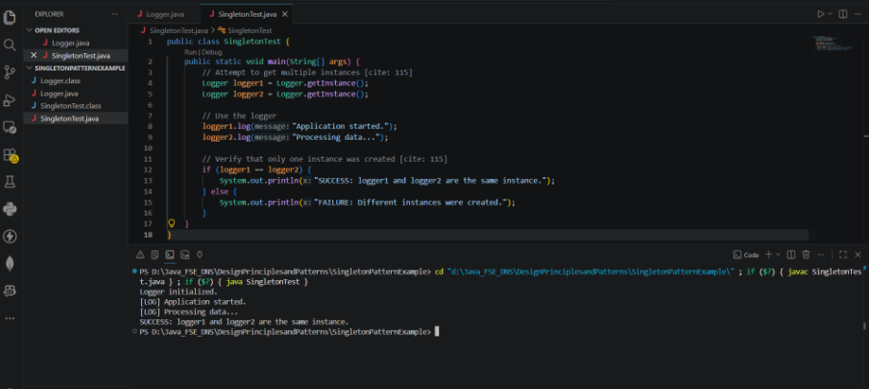

Exercise 2: Implementing the Factory Method Pattern
Scenario: You are developing a document management system that needs to create different types of documents (e.g., Word, PDF, Excel).

Document.java
public interface Document {
void open();
void save();
}

WordDocument.java
public class WordDocument implements Document {
@Override
public void open() {
System.out.println("Opening Word Document...");
}
@Override
public void save() {
System.out.println("Saving Word Document...");
}
}

PdfDocument.java
public class PdfDocument implements Document {
@Override
public void open() {
System.out.println("Opening PDF Document...");
}
@Override
public void save() {
System.out.println("Saving PDF Document...");
}
}

ExcelDocument.java
public class ExcelDocument implements Document {
@Override
public void open() {
System.out.println("Opening Excel Document...");
}
@Override
public void save() {
System.out.println("Saving Excel Document...");
}
}

DocumentFactory.java
public abstract class DocumentFactory {
public abstract Document createDocument();
}

WordDocumentFactory.java
public class WordDocumentFactory extends DocumentFactory {
@Override
public Document createDocument() {
return new WordDocument();
}
}

PdfDocumentFactory.java
public class PdfDocumentFactory extends DocumentFactory {
@Override
public Document createDocument() {
return new PdfDocument();
}
}

ExcelDocumentFactory.java
public class ExcelDocumentFactory extends DocumentFactory {
@Override
public Document createDocument() {
return new ExcelDocument();
}
}

FactoryMethodTest.java
public class FactoryMethodTest {
public static void main(String[] args) {
DocumentFactory wordFactory = new WordDocumentFactory();
Document wordDoc = wordFactory.createDocument();
wordDoc.open();
wordDoc.save();
System.out.println("-------------------------");
DocumentFactory pdfFactory = new PdfDocumentFactory();
Document pdfDoc = pdfFactory.createDocument();
pdfDoc.open();
pdfDoc.save();
System.out.println("-------------------------");
DocumentFactory excelFactory = new ExcelDocumentFactory();
Document excelDoc = excelFactory.createDocument();
excelDoc.open();
excelDoc.save();
}
}
